Benefits of Breastfeeding

Breastfeeding Protects Babies
- Early breast milk is liquid gold – Known as liquid gold, colostrum (coh-LOSS-trum) is the thick yellow first breast milk that you make during pregnancy and just after birth. This milk is very rich in nutrients and antibodies to protect your baby. Although your baby only gets a small amount of colostrum at each feeding, it matches the amount his or her tiny stomach can hold. (Visit How to know your baby is getting enough milk to see just how small your newborn’s tummy is!
- Your breast milk changes as your baby grows – Colostrum changes into what is called mature milk. By the third to fifth day after birth, this mature breast milk has just the right amount of fat, sugar, water, and protein to help your baby continue to grow. It is a thinner type of milk than colostrum, but it provides all of the nutrients and antibodies your baby needs.
- Breast milk is easier to digest – For most babies — especially premature babies — breast milk is easier to digest than formula. The proteins in formula are made from cow’s milk and it takes time for babies’ stomachs to adjust to digesting them.
- Breast milk fights disease – The cells, hormones, and antibodies in breast milk protect babies from illness. This protection is unique; formula cannot match the chemical makeup of human breast milk. In fact, among formula-fed babies, ear infections and diarrhea are more common. Formula-fed babies also have higher risks of: ◦Necrotizing (nek-roh-TEYE-zing) enterocolitis (en-TUR-oh-coh-lyt-iss), a disease that affects the gastrointestinal tract in preterm infants.
5. Lowers risk of chronic medical conditions:
- Lower respiratory infections
- Asthma
- Obesity
- Type 2 diabetes
- Some research shows that breastfeeding can also reduce the risk of Type 1 diabetes, childhood leukemia, and atopic dermatitis (a type of skin rash) in babies. Breastfeeding has also been shown to lower the risk of SIDS (sudden infant death syndrome).

Mothers Benefit From Breastfeeding
- Life can be easier when you breastfeed – Breastfeeding may take a little more effort than formula feeding at first. But it can make life easier once you and your baby settle into a good routine. Plus, when you breastfeed, there are no bottles and nipples to sterilize. You do not have to buy, measure, and mix formulas. And there are no bottles to warm in the middle of the night! You can satisfy your baby’s hunger right away when breastfeeding.
- Breastfeeding can save money – Formula and feeding supplies can cost well over $1,500 each year, depending on how much your baby eats. Breastfed babies are also sick less often, which can lower health care costs.
- Breastfeeding can feel great – Physical contact is important to newborns. It can help them feel more secure, warm, and comforted. Mothers can benefit from this closeness, as well. Breastfeeding requires a mother to take some quiet, relaxed time to bond. The skin-to-skin contact can boost the mother’s oxytocin (OKS-ee-TOH-suhn) levels. Oxytocin is a hormone that helps milk flow and can calm the mother.
- Breastfeeding can be good for the Mother’s health too – Breastfeeding is linked to a lower risk of these health problems in women:
- Type 2 diabetes
- Breast cancer
- Ovarian cancer
- Postpartum depression
- Experts are still looking at the effects of breastfeeding on osteoporosis and weight loss after birth. Many studies have reported greater weight loss for breastfeeding mothers than for those who don’t. But more research is needed to understand if a strong link exists.
- Mothers miss less work – Breastfeeding mothers miss fewer days from work because their infants are sick less often.

Breastfeeding Benefits Society
  - The nation benefits overall when mothers breastfeed. Recent research shows that if 90 percent of families breastfed exclusively for 6 months, nearly 1,000 deaths among infants could be prevented. The United States would also save $13 billion per year — medical care costs are lower for fully breastfed infants than never-breastfed infants. Breastfed infants typically need fewer sick care visits, prescriptions, and hospitalizations.
  - Breastfeeding also contributes to a more productive workforce since mothers miss less work to care for sick infants. Employer medical costs are also lower.
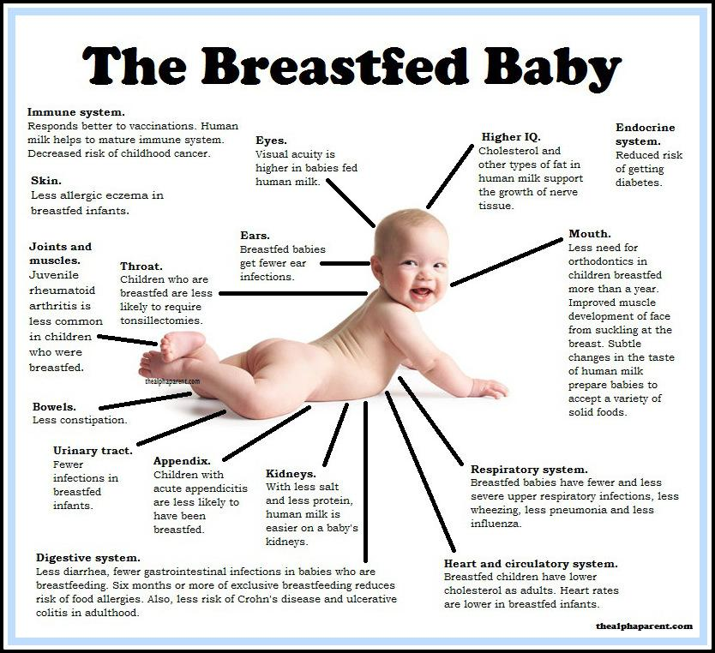
  - Breastfeeding is also better for the environment. There is less trash and plastic waste compared to that produced by formula cans and bottle supplies.

